**Project Design Phase-II**

**Data Flow Diagram & User Stories**

|  |  |
| --- | --- |
| Date | 27 October 2022 |
| Team ID | PNT2022TMID31052 |
| Project Name | Emerging Methods for Early Detection ofForest Fires |
| Maximum Marks | 4 Marks |

# Data Flow Diagrams:

A Data Flow Diagram (DFD) is a traditional visual representation of the information flows within a system. A neat and clear DFD can depict the right amount of the system requirement graphically. It shows how data enters and leaves the system, what changes the information, and where data is stored.

**DFD (Working)**

Flow

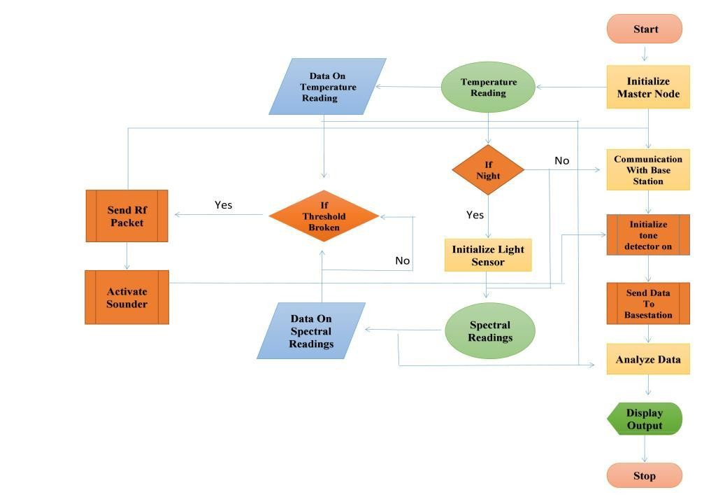

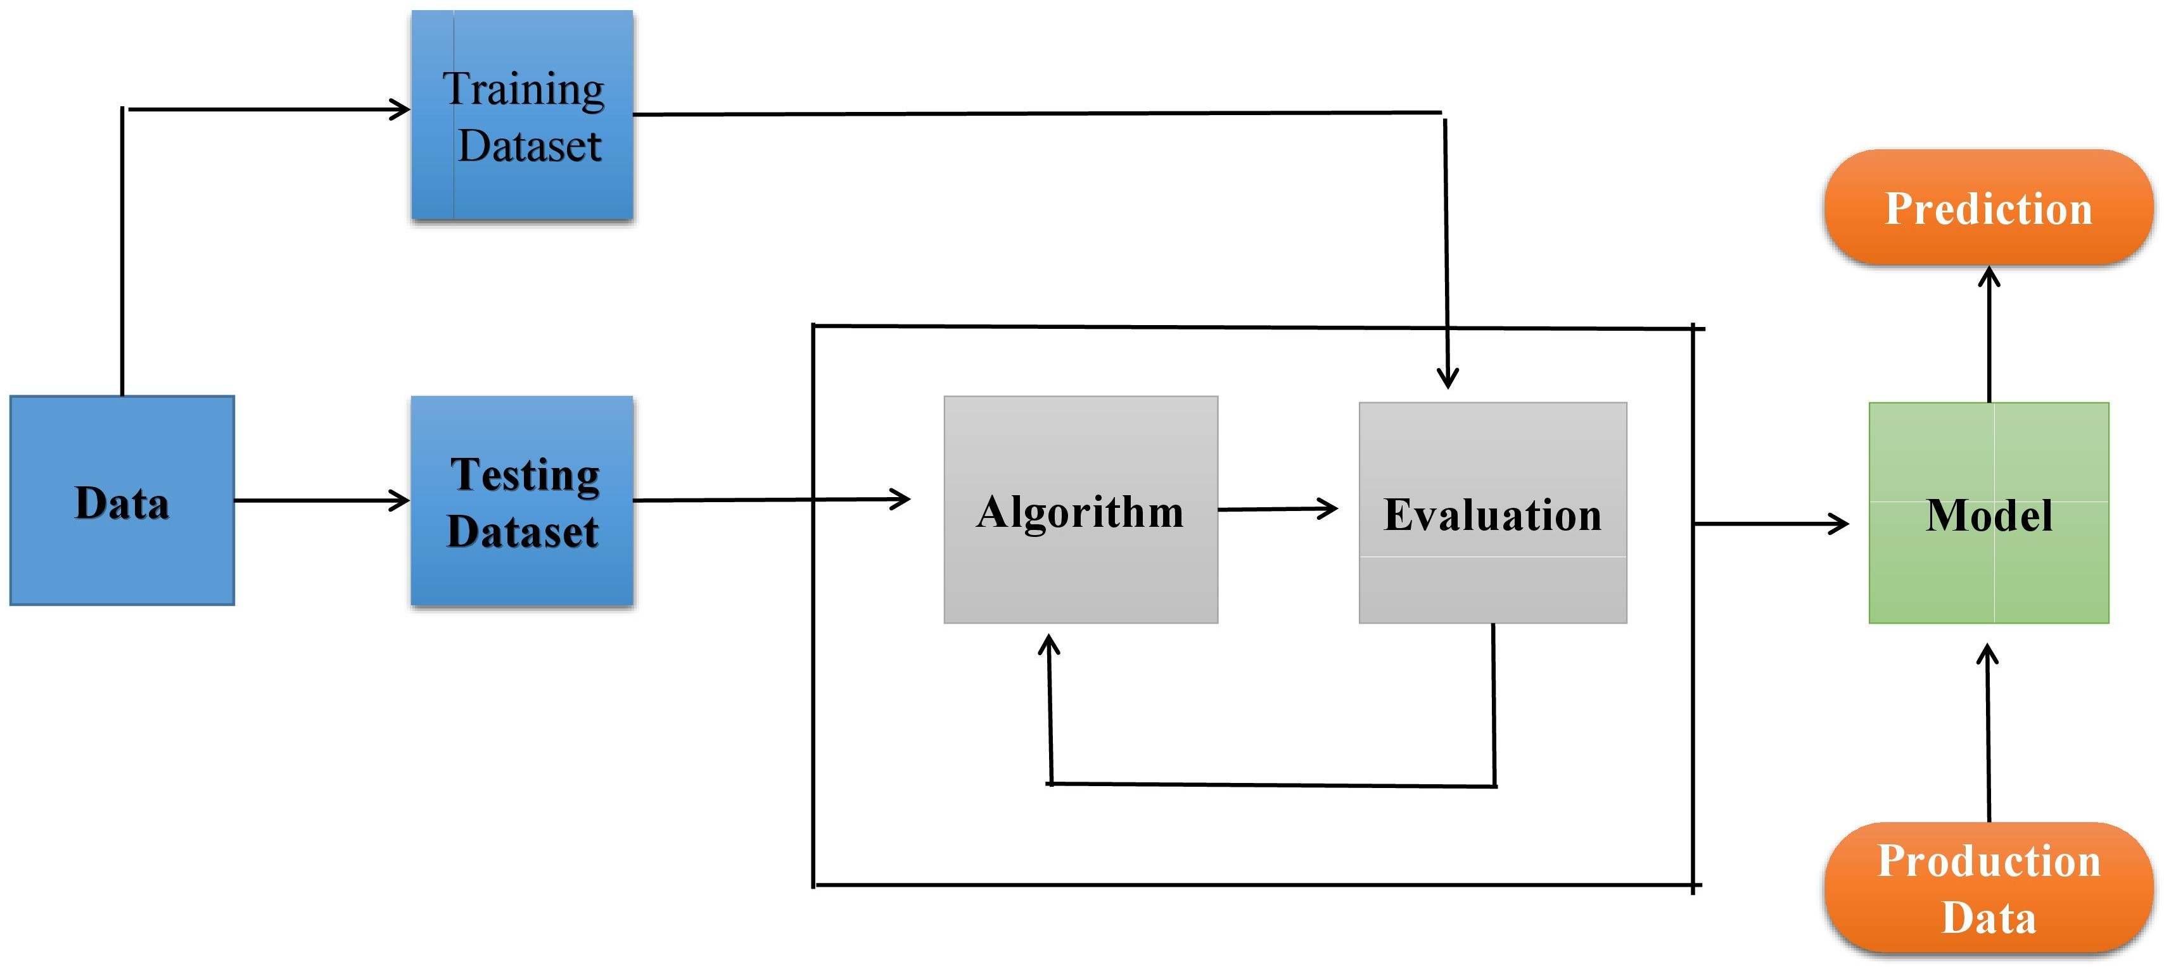

1. Collect data
2. Evaluate data set
3. Implement algorithms
4. Evaluate the accuracy of each algorithms
5. Display results

# User Stories

Use the below template to list all the user stories for the product.

|  |  |  |  |  |  |  |
| --- | --- | --- | --- | --- | --- | --- |
| **User Type** | **Functional Requireme nt(Epic)** | **User Story Number** | **User Story / Task** | **Acceptance criteria** | **Priority** | **Release** |
| Environmentalist | Collect the data | USN-1 | As an Environmentalist,it is necessary to collect the data of the forest which includes temperature,humidity,wind and rain of the forest | It is necessary to collect the right data else the prediction may become wrong | High | Sprint-1 |
|  |  | USN-2 | Identify algorithms that can be used for prediction | To collect the algorithm to identify the accuracy level of each algorithm | Medium | Sprint-2 |
|  |  | USN-3 | Identify the accuracy of each algorithms | Accuracy of each algorithm-calculated so that it is easy to obtain the most accurate output | High | Sprint-2 |
|  |  | USN-4 | Evaluate the Dataset | Data is evaluated before processing | Medium | Sprint-1 |
|  |  | USN-5 | Identify accuracy,precision,recall of each algorithms | These values are important for obtaining the right output | High | Sprint-3 |
|  |  | USN-6 | Outputs from each algorithm are obtained | It is highly used to predict the effect and to take precautionary measures. | High | Sprint-4 |